Test the performance of the data object(SortedList,SortedSet,SortedDictionary)
Test 1: Use BenchmarkDotNet to perform benchmarking and compare the performance differences among the three data structures: SortedList, SortedDictionary, and SortedSet.The comparison was conducted with both 100,000 and 1,000,000 users, and the results showed that SortedSet delivered the best performance.
The results as follows:
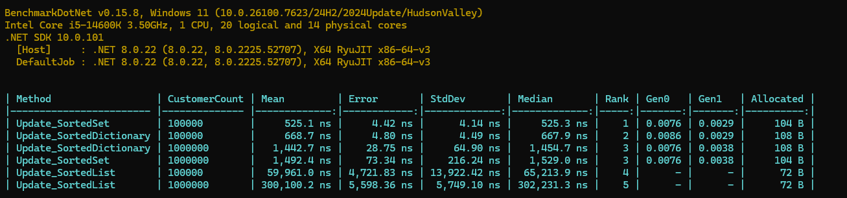

Test the performance difference between Lock and ReaderWritedLockSlim under identical conditions:

Initialize with 5 million records

100 task,each performing 100 operations.
Test 1:Write-only
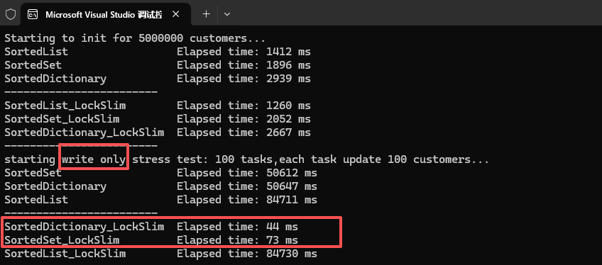
Test 2:30% for read,70% for write
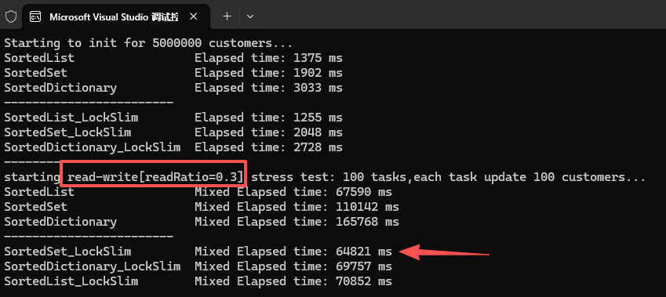
Test 3:50% for read,50% for write
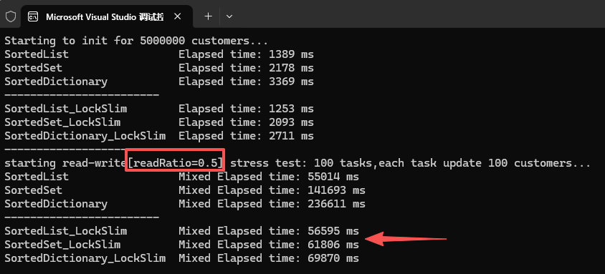
Test4:70% for read,30% for write
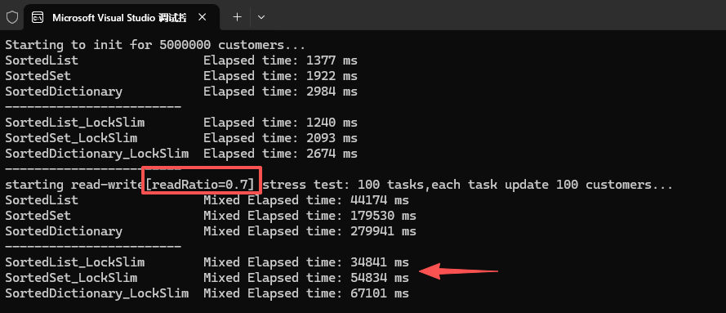
Conclusion：from the results,combining ReaderWriterLockSlim with SortedSet delivers the best performance.

